|  |  |
| --- | --- |
| IT PAT  2023 | Joshua Le Roux  Grade 12 |

Table of Contents

Task 1 3

A: Define the Task 3

B: User Story and Acceptance Test 4

Task 2: Design the Database 5

Task 3: Data Dictionary 6

Task 4 7

A: Navigation/Description of Flow Diagram 7

B: GUI Design 8

Task 5: IPO and Data Validation 11

ANNEXURE B: LEARNER DECLARATION 12

ANNEXURE C: DECLARATION OF AUTHENTICITY 0

Figure 1: Log In page 8

Figure 2: Sign-Up page 8

Figure 3: Home page 9

Figure 4: Admin settings 9

Figure 5: Species page 10

Figure 6: Fund-Raisers page 10

Table 1: Relationship key 5

# Task 1

## A: Define the Task

The environment is constantly changing, and there is an increasing need to become aware of the environmental issues around us. The responsibility lies with us to do more to protect and save our planet, with the preservation of endangered species becoming more urgent. This project sets out to develop a comprehensive information system that will serve as a catalyst for action, bridging the gap between awareness and real efforts to safeguard our environment, and the endangered animals in it.

In order to assist in keeping track of fund-raiser events and educating people about endangered animals, we have been tasked with creating and developing an interactive system to manage fund-raising projects that aim at saving and protecting endangered animals. While also being able to provide information about the endangered species these fund-raisers are for. The program should make the managing and updating of these events easier by providing a simple, understandable, yet functional interface.

The final program must comprise of one single project with logically related parts. It should allow admins to edit fund-raiser details and manage users on the system. The program should also allow standard users to be able to view information about the fund-raisers and learn about the various endangered species.

## B: User Story and Acceptance Test

|  |  |  |  |  |  |  |
| --- | --- | --- | --- | --- | --- | --- |
| **Who** | | **What** | | **Why** | | |
| *As a(n)…* | Admin | *I want to…* | Update fund-raising.  Edit standard user accounts. | | *So that…* | New donations or changing goal amounts can be reflected.  Unwanted users can be deleted. |
| User | View fund-raiser data.  Learn about endangered animals. | | I know where help is needed most.  I can stay informed about various endangered species. |

# Task 2: Design the Database

|  |  |  |
| --- | --- | --- |
| **tblAnimals** | | |
| **Animal** | Short Text | 20 |
| **EndangeredLevel** | Short Text | 25 |
| **Continent** | Short Text | 15 |

|  |  |  |
| --- | --- | --- |
| **tblFundraisers** | | |
| **ProjectCode** | Short Text | 5 |
| **ProjectName** | Short Text | 25 |
| **Organiser** | Short Text | 25 |
| **Animal** | Short Text | 20 |
| **GoalAmount** | Currency |  |
| **MoneyRaised** | Currency |  |

|  |  |  |
| --- | --- | --- |
| **tblUsers** | | |
| **Username** | Short Text | 30 |
| **Password** | Short Text | 30 |
| **Privileges** | Yes/No |  |

|  |  |  |
| --- | --- | --- |
| ***Relationship*** | | |
| One |  | Many |

Table : Relationship key

# Task 3: Data Dictionary

|  |  |  |
| --- | --- | --- |
| **Task** | **Object (Component)** | **Event (Procedure)** |
| Undo database changes. | Text file | Once edits have been made to the databases, if all edits are needing to be removed (reset to default), the user can restore the original state from the text file. |
| Store user/fund-raiser details. | Array (1D and 2D) | Extracted data is stored in various arrays for easier access. |
| To String | Function | Takes values and formats them into a string to form a short description. |
| Instantiate object. | Constructor create | Sends variable values to oop unit to be used with ToString function. |

# Task 4

## A: Navigation/Description of Flow Diagram

## B: GUI Design

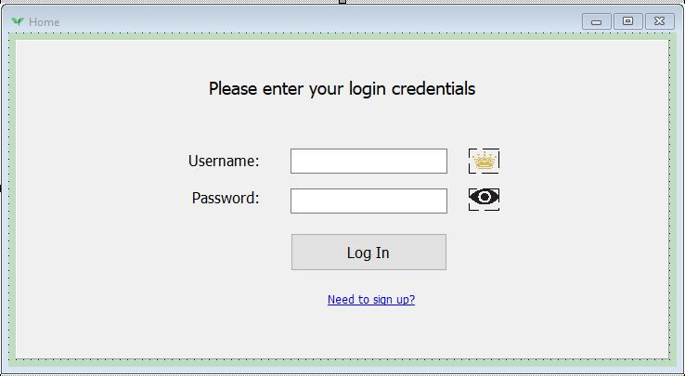

Figure : Log In page

The crown icon shows when an admin username is input.

Panel hides when valid credentials are used.

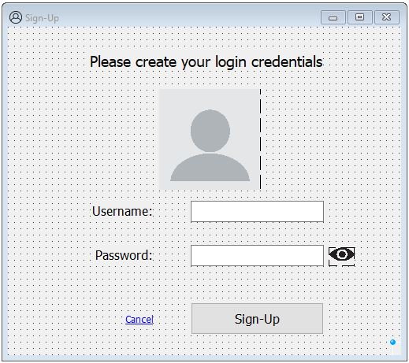

Figure : Sign-Up page

**Standardized plain interface for both the log in and sign-up pages.**

Figure : Home page

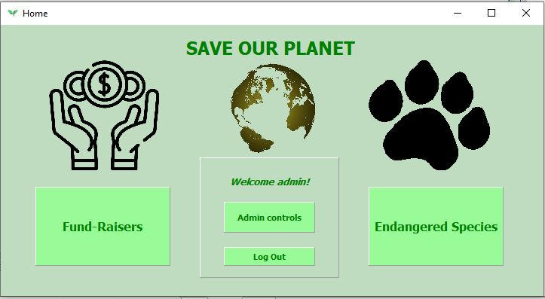

Color code: $98FB98

Used for clickable panels.

Admin controls hides if a non-admin user is logged in.

**Standardized green and blue interface for the rest of the program.**

Figure : Admin settings

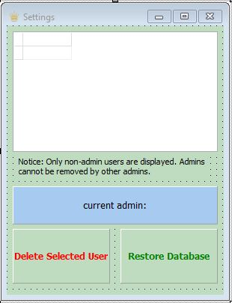

Non-clickable blue panel, used to display.

Panels load with the standardized $98FB98 color code.

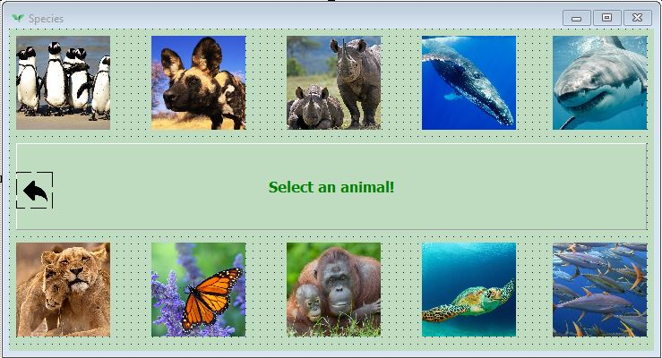

MoneyGreen panel used to give instructions, non-clickable.

Individual animal images used as buttons.

Back arrow to return to home.

Figure : Species page

Figure : Fund-Raisers page

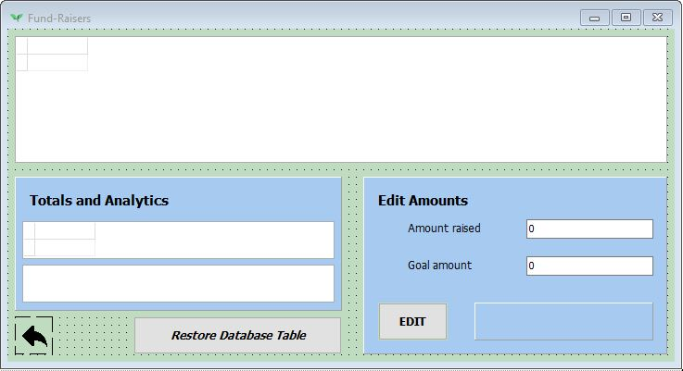

Traditional buttons used for edit and restore.

Blue panels used as backgrounds for related components.

# Task 5: IPO and Data Validation

|  |  |  |  |
| --- | --- | --- | --- |
| **Input** | **Process** | **Output** | **How** |
| ***Fund-Raisers*** | | | |
| Input new goal and raised amounts using the edit boxes. | Extracts new data from the edit fields. | Edits database with new data. |  |
| Ensures null (0) edits not applied. | Blank edit not applied. | if edt.Text > 0 then  ADOTable := edt.Text; |
| Click the restore database button. | Extracts data from text file to array. | Populates the 1D array. |  |
| Uses string handling to interpret data and write to database. | Writes data to database and displays on tdbGrid. | H := pos(‘#’,arr[L]);  str := copy(arr,1,H-1); |
| (onshow) Totals | Calculates totals from database table. | Displays the totals using SQL. |  |
| ***Species*** | | | |
| Select an animal’s picture. | Extract chosen animal’s data from database. | Assign to variables. |  |
| Instantiate object. | Get result from ToString. |  |
| Pull result from ToString function. | Display str in an Information dialog. |  |

ANNEXURE B: LEARNER DECLARATION

**Learner declaration – Phase 1 and 2**

I understand that work submitted for assessment must be my own. Have you received help/information from anyone to produce this work?

* No ☑Yes (provide details below)

|  |  |
| --- | --- |
| Help/Information received from (person): | Nature of the help/information (provide evidence): |
| Mr Long | [YouTube Tutorial](https://youtu.be/uaK_FZzmXug) – Using SQL to display database data. |
| JLR 20 / 08 / 2023  SIGNATURE OF LEARNER DATE | |

ANNEXURE C: DECLARATION OF AUTHENTICITY

**Declaration of authenticity**

|  |  |  |  |
| --- | --- | --- | --- |
| **Learner name** | Joshua Le Roux | **ID number** | 0506095744088 |
| **Grade** | 12 | **Year** | 2023 |
| **Subject** | INFORMATION TECHNOLOGY | | |
| Practical Assessment Task (PAT) | | **Teacher** | Mr Choudhury |
| I hereby declare that the contents of this assessment task are my own original work (except where there is clear acknowledgement and appropriate reference to the work of others) and have not been plagiarized, copied from someone else or previously submitted for assessment by anyone. | | | |
| JLR 20 / 08 / 2023  SIGNATURE OF LEARNER DATE | | | |